Open design studio:

* Right click on ocean-lbg and select “remove repository from view “ (find in below picture)
* Do once again

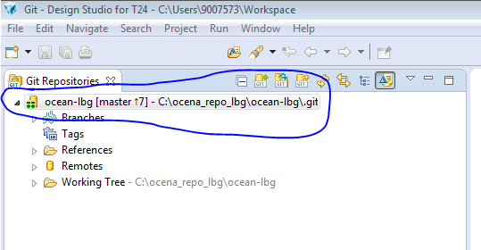

* Click on below icon or select “add an existing local Git repository

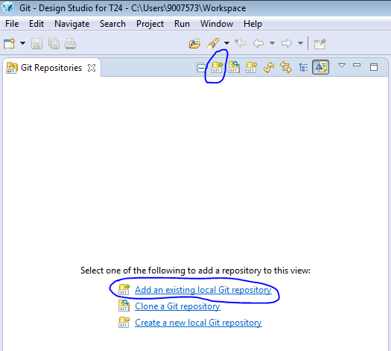

* Click on browse and navigate the repo where you cloned and click Ok

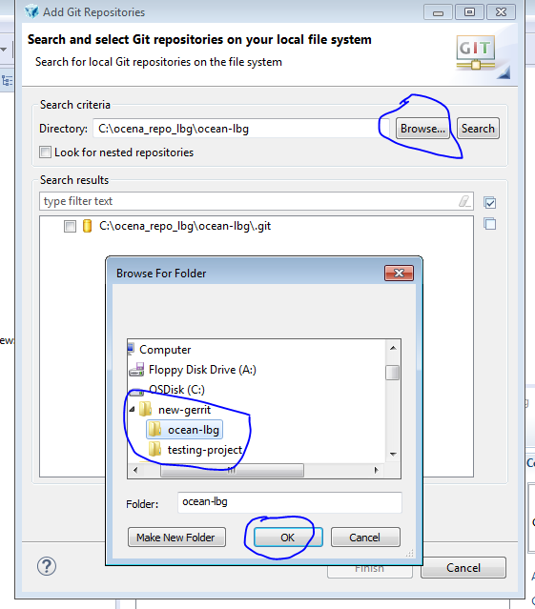

* Check on searched result and click finish button

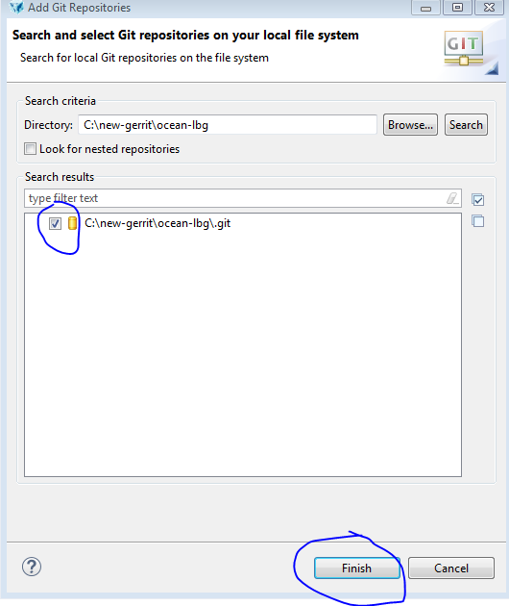

* Now you can see new cloned repository

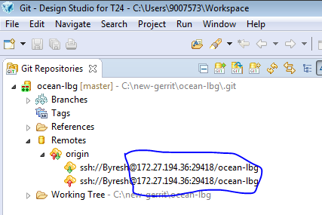

BY

Byresh